13.11.2019
студент P3113:
Егошин Алексей Васильевич

Преподаватель:
Малышева Татьяна Александровна
Лабораторная работа №5
По информатике

- Table of contents
1. Table of contents 1
2. The scripting programming language “Squirrel” 2
2.1. A general description and the history of creating 2
2.2. The data types system and features of language architecture 2
2.3. Samples and interesting fact 2
3. The general-purpose programming language “Oberon-07” 3
3.1. A general description and the history of creating 3
3.2. The data types system and features of language architecture 3
3.3. Samples and interesting facts 3
4. The Facebook programming language “Hack” 4
4.1. A general description and the history of creating 4
4.2. The data types system and features of language architecture 4
4.3. Samples and interesting facts 4
5. Samples 5
6. The quiz 6

- The scripting programming language “Squirrel”
Paradigm | Typing | Cross-platform | Memory management
Multi | Dynamic | Yes | Auto
Language summary table 1
  - A general description and the history of creating
"Squirrel is a high level imperative, object-oriented programming language, designed to be a light-weight scripting language that fits in the size, memory bandwidth, and real-time requirements of applications like video games." (1)
“The language was made public in 2003 under the zlib/libpng license. In November 2010, the license was changed to MIT license to enable the project to be hosted on Google Code. It is developed and maintained by Alberto Demichelis.” (2)
  - The data types system and features of language architecture
“Squirrel is a dynamically typed language so variables do not have a type, although they refer to a value that does have a type. Squirrel basic types are integer, float, string, null, table, array, function, generator, class, instance, bool, thread and userdata.
Dynamic typing, Delegation, Classes, inheritance, Higher order functions, Generators, Cooperative threads (coroutines), Tail recursion, Exception handling, Automatic memory management (mainly reference counting with backup garbage collector), Weak references, Both compiler and virtual machine fit together in about 7k lines of C++ code, Optional 16-bit character strings.’’ (3)
  - Samples and interesting fact
Look Sample 1 if you are looking for a code example.
An interesting fact: games using Squirrel:
- Left 4 Dead 2
- Portal 2
- Alien Swarm

- The general-purpose programming language “Oberon-07”
Paradigm | Typing | Cross-platform | Memory management
Imperative, structured, modular, object-oriented | Static | No | Auto
Language summary table 2
  - A general description and the history of creating
“Oberon is a general-purpose programming language created in 1986 by Niklaus Wirth and the latest member of the Wirthian family of ALGOL-like languages (Euler, Algol-W, Pascal, Modula, and Modula-2). Oberon was the result of a concentrated effort to increase the power of Modula-2, the direct successor of Pascal, and simultaneously to reduce its complexity. Its principal new feature is the concept of type extension of record types: It permits the construction of new data types on the basis of existing ones and to relate them, deviating from the dogma of strictly static data typing. Type extension is Wirth's way of inheritance reflecting the viewpoint of the parent site. Oberon was developed as part of the implementation of the Oberon operating system at ETH Zurich in Switzerland. The name is from the moon of Uranus, Oberon.
Oberon is designed with a motto attributed to Albert Einstein in mind: “Make things as simple as possible, but not simpler.” The principal guideline was to concentrate on features that are basic and essential and to omit ephemeral issues. Another factor was recognition of the growth of complexity in languages such as C++ and Ada: in contrast to these, Oberon emphasizes the use of the library concept for extending the language. Enumeration and subrange types, which were present in Modula-2, have been removed; similarly, set types have been limited to small sets of integers, and the number of low-level facilities has been sharply reduced (most particularly, type transfer functions have been eliminated). Elimination of the remaining potentially-unsafe facilities concludes the most essential step toward obtaining a truly high-level language. Very close type-checking even across modules, strict index-checking at run time, null-pointer checking, and the safe type extension concept largely allow the programmer to rely on the language rules alone.
The intent of this strategy was to produce a language that is easier to learn, simpler to implement, and very efficient. Oberon compilers have been viewed as compact and fast, while providing adequate code quality compared to commercial compilers.” (4)
  - The data types system and features of language architecture
“Oberon-07, defined by Niklaus Wirth in 2007 and revised in 2011, 2013, 2014, 2015 and 2016 is based on the original version of Oberon rather than Oberon-2. The main changes are: explicit numeric conversion functions (e.g. FLOOR and FLT) must be used, the LOOP and EXIT statements have been eliminated, WHILE statements have been extended, CASE statements can be used for type extension tests, RETURN statements can only be connected to the end of a function, imported variables and structured value parameters are read-only and arrays can be assigned without using COPY. For full details, see The Programming Language Oberon-07.
Oberon-07 compilers have been developed for use with several different computer systems. Wirth's compiler targets a RISC processor of his own design that was used to implement the 2013 version of the Project Oberon operating system on a Xilinx FPGA Spartan-3 board. Ports of the RISC processor to FPGA Spartan-6, Spartan-7, Artix-7 and a RISC emulator for Windows (compilable on Linux and OS X, as well as binaries available for Windows) also exist. OBNC compiles via C and can be used on any POSIX compatible operating system. The commercial Astrobe implementation targets 32-bit ARM Cortex-M3, M4 and M7 microcontrollers. The Patchouli compiler produces 64-bit Windows binaries. Oberon-07M produces 32-bit Windows binaries and implements revision 2008 of the language. Akron's produces binaries for both Windows and Linux. oberonjs translates Oberon to JavaScript, while oberonc is an implementation for the Java virtual machine.”
  - Samples and interesting facts
Look Sample 2 if you are looking for a code example.
An interesting fact: several dialects of Oberon language exist: Oberon-2, ETH Oberon, Oberon SA, Oberon-07, Active Oberon.

- The Facebook programming language “Hack”
Paradigm | Typing | Cross-platform | Memory management
Multi | Gradual | Yes | Auto
Language summary table 3
  - A general description and the history of creating
“Hack is a programming language for the HipHop Virtual Machine (HHVM), created by Facebook as a dialect of PHP. The language implementation is open-source, licensed under the MIT License.
Hack allows programmers to use both dynamic typing and static typing. This kind of a type system is called gradual typing, which is also implemented in other programming languages such as ActionScript. Hack's type system allows types to be specified for function arguments, function return values, and class properties; however, types of local variables are always inferred and cannot be specified.
Hack was introduced on March 20, 2014. Before the announcement of the new programming language, Facebook had already implemented the code and "battle tested" it on a large portion of its web site.” (5)
  - The data types system and features of language architecture
“Hack is designed to interoperate seamlessly with PHP, which is a widely used open-source scripting language that has a focus on web development and can be embedded into HTML. A majority of valid PHP scripts are also valid in Hack; however, numerous less frequently used PHP features and language constructs are not supported in Hack.
Hack extends the type hinting available in PHP 5 through the introduction of static typing, by adding new type hints (for example, for scalar types such as integer or string), as well as by extending the use of type hints (for example, for class properties or function return values). However, types of local variables cannot be specified. Since Hack uses a gradual typing system, in the default mode, type annotations are not mandatory even in places they cannot be inferred; the type system will assume the author is correct and admit the code. However, a "strict" mode is available which requires such annotations, and thus enforces fully sound code.” (5)
  - Samples and interesting facts
Look Sample 3 if you are looking for a code example.
An interesting fact: Hack was created by Facebook.

- Samples
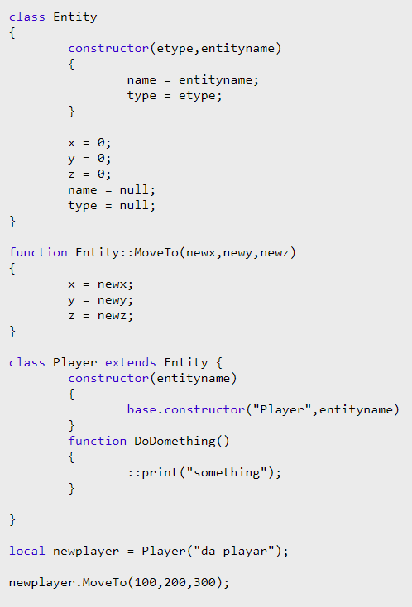
Sample 1

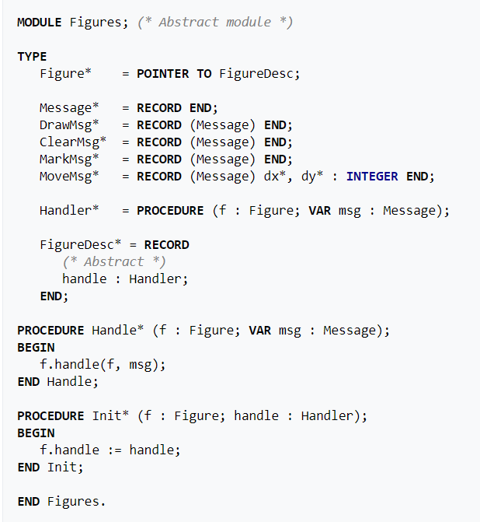
Sample 2

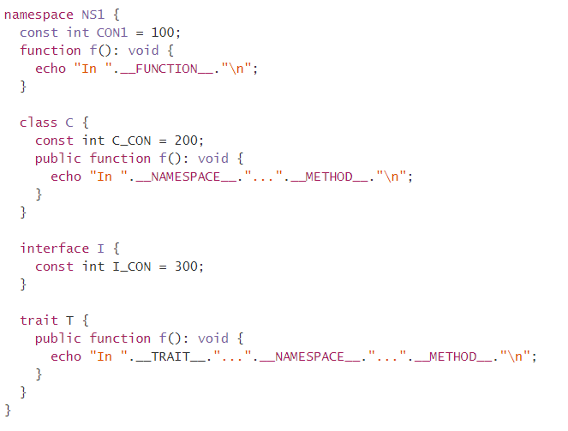
Sample 3
- The list of used literature
1. Demichelis, Alberto. Squirrel Home Page. Squirrel the programming language. [В Интернете] Alberto Demichelis, 2016 г. [Цитировано: 07 November 2019 г.] http://squirrel-lang.org/.
2. World. Squirrel (programming language). WikipediA The Free Encyclopedia. [В Интернете] 28 September 2019 г. [Цитировано: 07 November 2019 г.] https://en.wikipedia.org/wiki/Squirrel_(programming_language).
3. Demichelis, Alberto. Squirrel 3.1 Reference Manual 2.2. Values and Data types. Squirrel documentation. [В Интернете] Alberto Demichelis, 2016 г. [Цитировано: 07 November 2019 г.] http://squirrel-lang.org/squirreldoc/reference/language/datatypes.html.
4. World. Oberon (programming language). Wikipedia The Free Encyclopedia. [В Интернете] 11 October 2019 г. [Цитировано: 8 November 2019 г.] https://en.wikipedia.org/wiki/Oberon_(programming_language).
5. —. Hack (programming language). Wikipedia The Free Encyclopedia. [В Интернете] 27 September 2019 г. [Цитировано: 8 November 2019 г.] https://en.wikipedia.org/wiki/Hack_(programming_language).

- The quiz
  - Which of mentioned languages was created first?
Choose an answer:
  - Which languages have the auto memory control?
  - Which of mentioned languages are more useful for creating games?
  - Which of mentioned languages do you like more?

